OPCN2 Sample Flow Rate Testing

The first test was undertaken for 100 seconds, first with the housing then without (shown below). This test initially gave the impression that the flow rate was higher with the housing (**counter intuitive**). It can also be seen that the flow rate increases slowly over time for both tests, my guess is that this is due to the fan heating up and its internal friction reducing slightly.

The test was then repeated for a **longer period** (6 minutes) to verify the above. This is shown below.

This test showed that the flow rate magnitude is nearly the same for each configuration. It shows again the tendency for the flow rate to increase slightly over time. Interestingly it also shows this time that flow rate with the housing is a lot more variable/noisy. This makes me think it could have been one of the factors that made the OPCN2 data noisy when testing in the ash chamber last week (the particle readings are dependent on the flow rate readings).

**However flow rate seems to vary widely from test to test.**

General Flow Rate Info from OPCN2 Manual

“The sample air flow rate through the unit is determined by both the fan speed and any obstruction that affects the inlet or outflow of the OPC. Considering this problem- tubing, valves, baffles or obstructions that will restrict air flow into or out of the OPC should be avoided. Particle distribution can also be affected by sharp turns and narrow sample pipes. Maximum pressure drop through the entire flow system must be less than 75 Pa and ideally less than 40Pa.

However, because fan speed can vary and external factors such as wind direction in the vicinity of the OPC may affect the sample flow rate through the OPC, such variations are monitored and corrected dynamically by the OPC so that the particle concentrations and derived PM values are unaffected by moderate flow variations.”

“General running and features of 16 and 17 are the same in issue 18. All have dynamic correction for sample flow-rate caused by changes to the of the fan speed and also apply the respiratory profiles to the PM values” (We have issue 18)

# Checking Pressure Drop

Tried set up as below to check pressure drop through sensor.

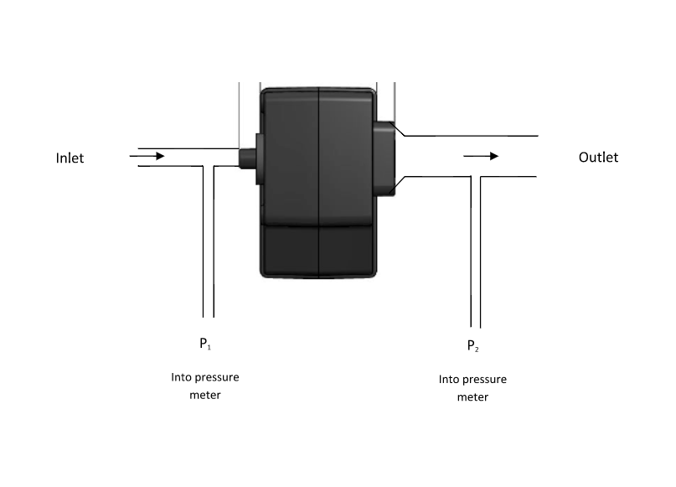

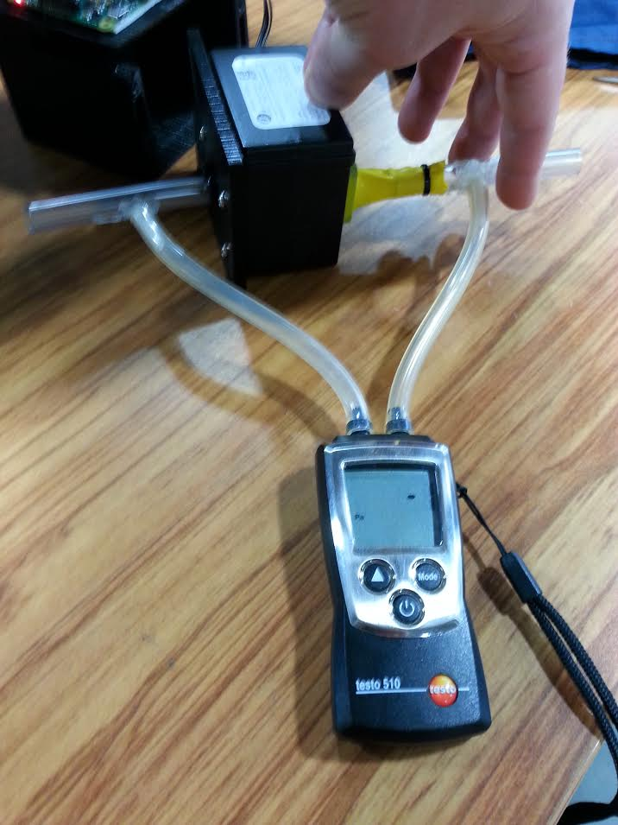

* Could only get a pressure drop of -1 Pa, less than 40 Pa as manual recommends.
* Fan is quite weak – found by other researchers too.

# Flow rate testing with Smoke

* Tested as below, but with smoke.
* Timed how long to empty jar of known volume

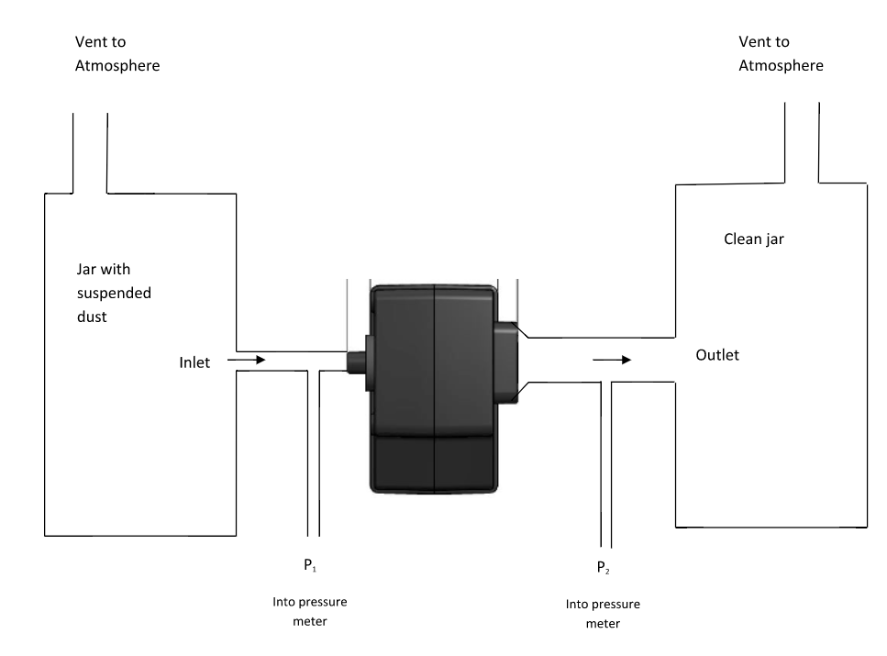

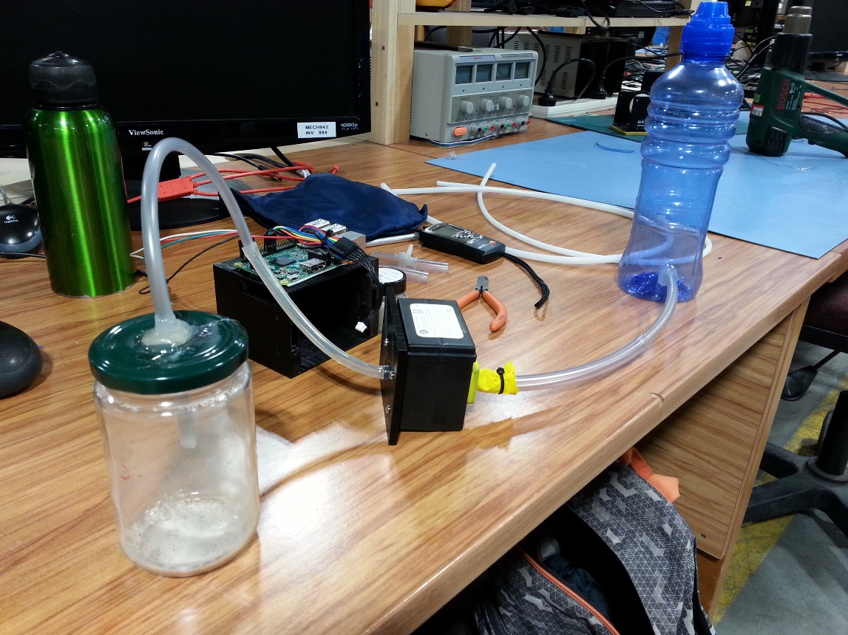

* Found flow rate to be 300-400 mL/min, but hard to measure – hard to tell when all smoke has left jar
* Manual given flow rate: 220 mL/min
* Flow rate from testing at start: approx. 150-240 mL/min